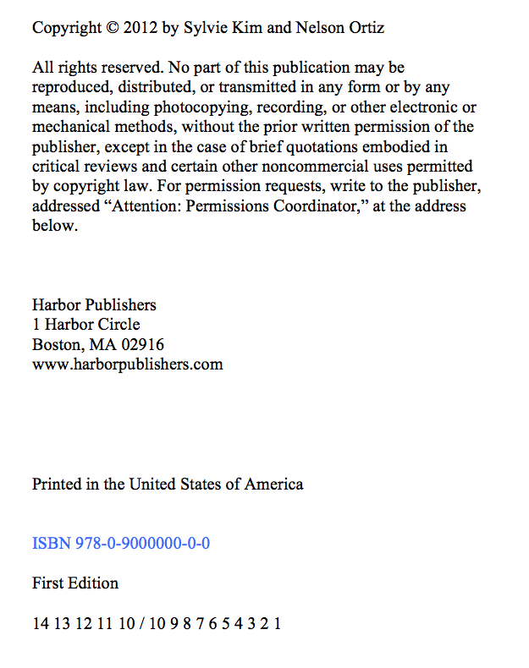

Volunteering:

Be the Best You Can Be

Sylvie Kim and Nelson Ortiz

Harbor Publishers

Scroll down to view the second source

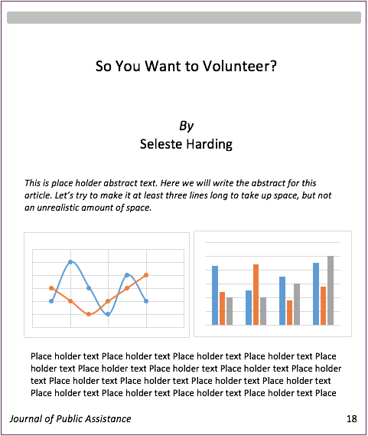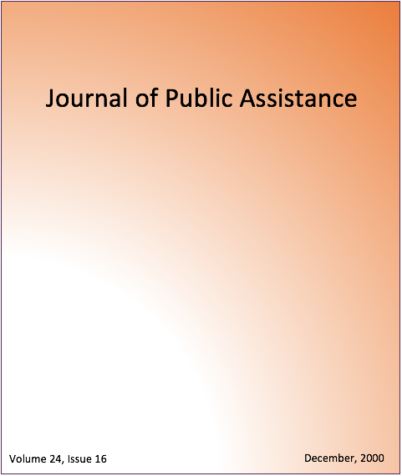

21

20

19